**Performance Testing Report**

**Observation:**

* Resource utilization (CPU and Memory) of the server (local machine/Docker container) is very low.
* Overall iteration time takes 2 to 2.10 seconds (including sleep time 2 seconds for each iteration)
* The server was able to perform the call and provide the response in 5.91 microseconds

**Status**: Pass

**Scenario Details**

|  |  |
| --- | --- |
| Number of Scripts | 1 |
| Script Name | StepUpScript.js |
| Description of the script | Retrieve the car details |
| Number of Vusers | 25 |
| Ramp up/down Pattern | Stage 1:  10 users in 10 seconds  Stage 2:  15 users in 20 seconds  Stage 3:  25 users in 30 seconds  Stage 4: Steady state  25 users in 900 seconds  Stage 5: Ramp down  0 users in 10 seconds |

**Result**

|  |  |
| --- | --- |
| Number of Iterations Performed | 11856 |
| Checks (Successful Rate) | 100% |
| Data Sent | 1.2 MB |
| Data Received | 3.1 MB |

|  |  |  |  |
| --- | --- | --- | --- |
| **Metrics** | **Average (microseconds)** | **90 percentiles (microseconds)** | **95 percentiles (microseconds)** |
| http_req_duration | 3.15 | 4.81 | 5.91 |
| http_req_tls_handshaking | 0 | 0 | 0 |
| http_req_blocked | 73.09 | 108.19 | 178.25 |
| http_req_connecting | 5.72 | 0 | 0 |
| Iteration duration | 2 | 2 | 2 |

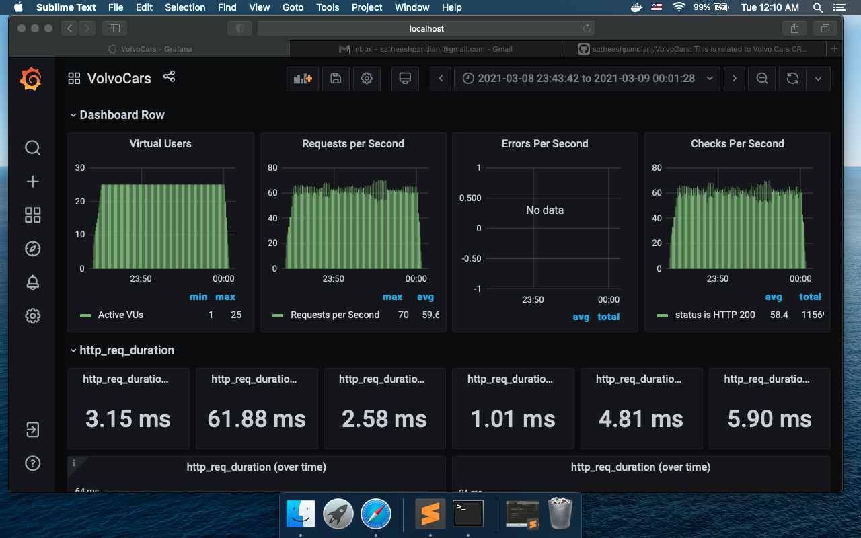

**Resource Utilization**

